Computing Graphs DFS using Python

Homework #12

By

Mario Pendleton

CS 303 [Algorithms and Data Structures](https://uab.instructure.com/courses/1507655)

November 17, 2019

### Problem Specification

Implement Depth First Search algorithm on graphs.

Implement Topological Sort

**Problem**

1. Write a program to implement the depth-first search algorithm using the pseudocode given on the next page.

2. Write a driver program, which reads input file mediumG.txt as an undirected graph and runs the depth-first search algorithm to find paths to all the other vertices considering 0 as the source. This driver program should display the paths in the following manner:

0 to ‘v’: list of all the vertices traversed to go to v from 0, separated by ‘,’ . There is another file called tinyG.txt which you can use for your testing purpose.

3. Implement the Topological Sort algorithm for directed graphs and run the algorithm on the directed graph that is provided in the tinyDG.txt file. The pseudocode is provided in the next page.

### Program Design

This program requires a linked list of data that will be searched using DSF. The core methods were design after the pseudo code below.

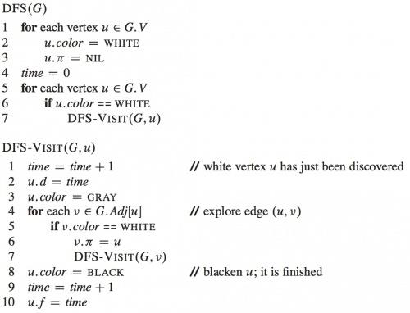

The following steps were required to develop this program:

1. Write a node class in python.

Class Node:

__init__(self, key) – Key value, Neighbors array, Parent Node, Node Color, Node distance, Node Finish

Methods within the class.

. printNode(self) – Prints a node stats.(key, data, left, right, parent, color)

. addNeighbor(self, v) – Adds an element to the array of neighbors.

. addNeighbors(self, vertices) – Appends an array of elements to the array of neighbors.

. Getters Key value, Neighbors array, Parent Node, Color, distance, Finish

1. Write a Graph class in python.

Class Graph

__init__(self) – Graph Dictionary , Q

Methods with the class.

. addVertex(self, v) – Inserts a node into the graph

. addVertices(self, v) – Inserts an array of nodes into the graph

. addEdge(self, u, v) – Establishes a connection between nodes u and v making them neighbors.

. printGraph(self) – Prints the sorted graph’s keys and corresponding neighbors.

. BSF(self, s) – Performs a Breadth First Search of the graph starting with node s.

. printPath(self, s, v) – Prints the shortest distance from node s to v after the BSF

. DFS() – Preps the node and calls DFSV(node)

. DFSV() – Perform actual DFS search and queuing

. DFSQ() - Places the results of DFS in the into the graphs.Q

|  |  |  |  |
| --- | --- | --- | --- |
| Test Case | Input Values | Output Values | Reverse Bubble Sort |
| (a) | loadNode(path) path = tinyG.txt | DFSQ: [13, 3, 4, 5, 1, 2, 6, 0, 12, 10, 11, 9, 8, 7] | 0.000146 |
| (b) | load(path1) path = tinyDG.txt | DFSQ: [13, 5, 5, 1, 2, 6, 0, 4, 3, 5, 3, 3, 4, 3, 1, 12, 12, 10, 11, 9, 12, 4, 4, 6, 2, 12, 12, 11, 10, 8, 8, 7, 8] | 0.00150 |
| (c) | load(path2) mediumG.txt | Large Out | 0.0139 |
|  |  |  |  |

1. Use the a method to read the following txt files and covert them into arrays to be sorted

* TinyG.txt
* mediumG.txt
* TinyDG.txt

### Testing Plan

In the node testing sample nodes were created (A,B,C,D,E,F,G,H,K,L,M,N,O). Corresponding the nodes found on tinyG.txt. A list of neighbors was established to situate the graph. The getters were then tested on node A. To test the graph a new instance of Graph was established. The pointer to graph and the empty graph dictionary were printed. Nodes (A,B,C,D,E,F,G,H,K,L,M,N,O) were then imported into the graph and printed. The graph is printed again using the printGraph() method. Once the graph was completed, DFS() is tested then performed on the files provided.

### Test Cases

The test cases are shown in the table below using a MacBook Pro 16GB, 8 core 2.3 GHz Intel Core i9:

### Analysis and Conclusions

### DSF was a success.

### References

Textbook, python.org, and examples provided in the assignment.

**Screen Shot**

